🎓
Xebia LMS Assessment Portal
Technical & Functional Documentation
An Enterprise-Grade Learning Management System Assessment & Resource Hub

Table of Contents
1. Project Overview
2. Features
3. Technology Stack & Services
4. System Architecture
5. Project Structure
6. Installation & Setup
7. Environment Variables
8. Login Credentials (Seeded) & Authentication Flow
9. REST API Reference
10. Database Schema & Collections
11. Teacher Workflow & Assessment Creation Flow
12. Student Workflow & Assessment Submission Flow
13. Grading & Feedback Workflow
14. File Management & Document Preview System
15. Feature Modules Breakdown
16. Certificate Generation Workflow
17. Deployment Guide
18. Security & Best Practices
19. Future Enhancements & Roadmap
20. Document Summary & Quick Reference

1. Project Overview

1.1 Purpose & Objective
The Xebia LMS Assessment Portal is a web-based Learning Management System designed to streamline academic testing and grading workflows for instructors and learners.
Traditional LMS platforms often treat assessment uploads as raw binary download links, forcing students to download files locally and install external software (such as MS Word or Adobe PDF) to view or edit them. This project solves that friction by implementing in-portal, binary-safe rendering for multiple document formats, keeping the learning and evaluation experience consolidated, secure, and fast.

1.2 Target Users
Role | Responsibilities
Teacher (Instructor) | Authors assessments (manual input or Excel import), configures deadlines, targets batches, uploads materials, and reviews/grades submissions
Learner (Student) | Filters assigned assessments by batch, reviews materials inline, downloads task sheets, uploads solutions, and tracks grades
Admin | User management and administrative configurations, handled by default seed data (not implemented as a UI role)

1.3 Key Statistics
- Frontend: React 19 + Next.js
- Backend: Java Spring Boot 2.7.18
- Database: MongoDB Atlas
- File Storage: Local Disk Storage

2. Features

2.1 Teacher Features
- Assessment Creator — choose between Manual Question Entry or Excel template importing.
- Save as Draft / Publish Assessment — drafts remain visible only to instructors; publishing makes the assessment visible to assigned students.
- Create New Batch — register new candidate groups dynamically from the assessment builder's batch selector.
- Multiple Batch Selection — target a single assessment to multiple student groups (Batch A, B, C, D, etc.) simultaneously.
- Submissions Review Desk — monitor student status dynamically: Pending, Submitted, Graded, Late, Missing.
- Bulk Actions — select multiple candidate rows to bulk-grade, bulk-mark reviewed, or bulk-download files.
- Grading & Comments — score written tests and leave constructive feedback.
- Materials Panel — upload shared class documents directly to local storage, linked via MongoDB references.

2.2 Learner Features
- Batch Locking — the system automatically retrieves the user's batch profile on login and locks the query filters, hiding batch selectors.
- MCQ Test Player — a responsive answer-options picker with direct submission capability.
- File Previewer — view attachments inline (PDF, DOCX, XLSX, CSV, images, text) directly in the browser.
- Solution Upload — a multipart file uploader for solved response files (max 5 MB).
- Marks Panel — monitor test grades and read instructor remarks.
- My Certificates Workspace — review unlocked enterprise-grade Xebia Academy credentials in a dedicated menu layout.
- Certificate Preview & PDF Exporter — preview certificates pixel-for-pixel via a styled SVG canvas wrapper, or generate high-quality PDF downloads.

2.3 Feature Modules Summary
- Assessment Module — manual creation, Excel sheet parsing, multi-batch assignment, draft/publish, student player attempts.
- File Management — attachment uploads, inline previews, forced file downloads.
- Quiz Management — MCQ option bindings, correct-answer toggle indicators, question outlines.
- Excel Import — client-side SheetJS template validation (columns, marks, type checks).
- Submission Management — table lists, sort options (Newest, Oldest, Marks), candidate search filters.
- Grading & Feedback — evaluation modal interface for marks entry and written remarks.
- Authentication — plain-text password matching against seeded accounts, with role-based view redirection.
- Dashboard — dynamic metrics cards panel.
- Search & Filters — multi-batch checkboxes, search inputs, time filters, sorting selectors.
- Materials — course document downloads and inline previews.
- Notifications — not implemented in the current project; system alerts are not present.

3. Technology Stack
Layer | Technology | Details
Frontend | React 19, Next.js (App Router), TypeScript | Client-side application optimized with Webpack
Styling | Vanilla CSS, Tailwind CSS | Curated professional dark/light flat enterprise theme
Backend | Java, Spring Boot 2.7.18 | REST API controllers, file streaming endpoints
Database | MongoDB Atlas | Cloud-hosted document database for metadata persistence
Authentication | Local Auth Context | Custom plain-text password mapping stored in localStorage
State Management | React Context API | AppContext sharing profile details and apiService calls
File Storage | Local Disk Storage | Physical directory ./uploads on backend server
Libraries | Mammoth.js, SheetJS (xlsx) | Client-side converters: docx-to-html and sheet-to-grid
Development Tools | Maven, NPM | Build automation tools and dependency managers

4. System Architecture
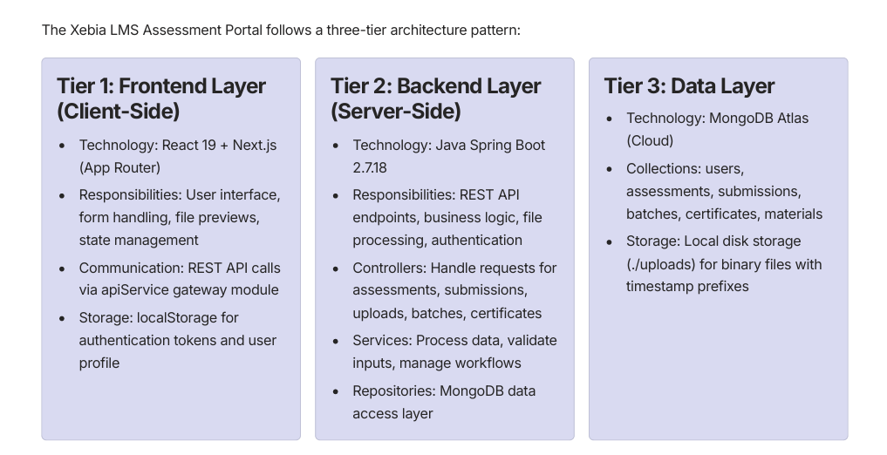.

Figure 1a — Three-tier architecture (Frontend, Backend, Data layers)

4.1 Data Flow Diagram

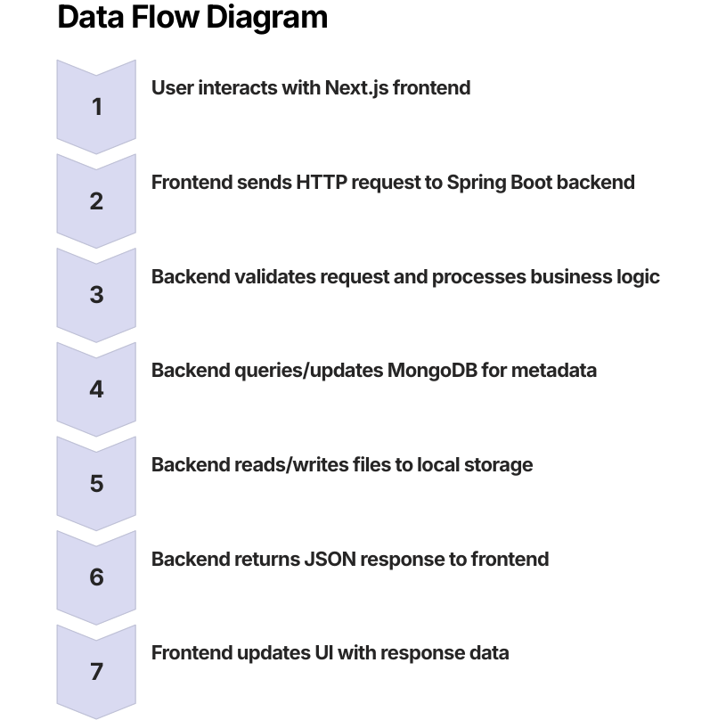

Figure 1b — End-to-end request/response data flow

4.2 Key Integration Points
- API Gateway: apiService.ts (Axios/Fetch wrapper).
- Authentication: Plain-text password validation against seeded accounts.
- File Processing: Mammoth.js (DOCX), SheetJS (Excel), native handlers (PDF, images).
- State Management: React Context API for the global user profile and API service.

5. Project Structure
assessment-portal1/
├── README.md
└── assessment-portal/
├── app/ # Next.js App Router (pages & navigation)
│ ├── assessments/ # Solve player, creator builder, and details views
│ ├── dashboard/ # Core metrics dashboard
│ ├── materials/ # Shared student guides
│ ├── marks/ # Student grades tracker
│ └── page.tsx # Login interface & role selector
├── components/
│ └── files/
│ └── FilePreviewModal.tsx # Document parser (Mammoth/SheetJS/Iframe)
├── lib/
│ ├── apiService.ts # Axios/Fetch API client gateway
│ └── context.tsx # Global context state provider
├── backend/
│ ├── pom.xml # Maven configuration
│ ├── src/main/java/com/assessmentportal/
│ │ ├── controller/ # API Rest Controllers (Upload, Auth, Submissions)
│ │ ├── model/ # MongoDB document entities
│ │ ├── repository/ # MongoRepository interfaces
│ │ └── seed/ # Seed data helper (DataSeeder.java)
│ └── src/main/resources/
│ └── application.properties # Database connection configurations
├── public/ # Static assets & brand logos
└── package.json # Frontend NPM configuration

6. Installation & Setup

6.1 Prerequisites
- Java JDK 17+ installed
- Node.js v18+ installed
- MongoDB Atlas cluster or local MongoDB running
- Git for version control

6.2 Clone the Repository
git clone https://github.com/Pardhu643/Xebia-LMS-assessment-portal.git
cd Xebia-LMS-assessment-portal

6.3 Configure Environment Variables
Create a local configuration profile or .env file containing:
SPRING_DATA_MONGODB_URI="your_mongodb_connection_uri"
NEXT_PUBLIC_API_URL="http://localhost:8080"

6.4 Build & Run Backend
cd assessment-portal/backend
# On Windows PowerShell
$env:SPRING_DATA_MONGODB_URI="your_mongodb_atlas_connection_string"
.\mvnw.cmd spring-boot:run
# On macOS/Linux
export SPRING_DATA_MONGODB_URI="your_mongodb_atlas_connection_string"
./mvnw spring-boot:run
The backend starts on http://localhost:8080.

6.5 Build & Run Frontend
cd ../ # Move back to assessment-portal root
npm install
npm run dev
Open http://localhost:3000 in your browser.

6.6 Verify Installation
- Open http://localhost:3000 in your browser.
- Log in with teacher@lms.com / teacher123.
- Check backend health at http://localhost:8080/api/assessments.

7. Environment Variables
Variable Name | Description | Default Fallback
SPRING_DATA_MONGODB_URI | Cloud MongoDB connection URI string | mongodb://localhost:27017/employeeDB
PORT | Spring Boot web server port | 8080

8. Login Credentials (Seeded) & Authentication Flow
The portal is seeded with the following credentials for local evaluation:
Role | Email / Username | Password | Access Level
Teacher | teacher@lms.com | teacher123 | Full assessment creation, resource upload, deadline configuration, submission review, and grading
Learner | learner@lms.com | learner123 | Assessment solving and submission, inline material preview, grade tracking

8.1 Authentication Flow
Login authenticates the user by matching plain-text credentials against seeded accounts, then redirects based on role, automatically locking the batch filter for learners.
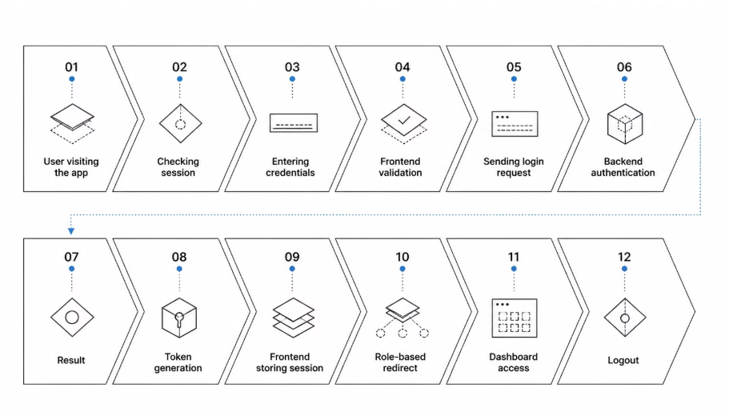

Figure 2 — Authentication flow
Here is a detailed breakdown of the complete authentication process:
- User Visits Application
  - Browser loads http://localhost:3000
  - Frontend checks localStorage for existing session token
- Session Check
  - If valid token exists → Redirect to dashboard
  - If no token → Display login page
- User Enters Credentials
  - Email/Username input
  - Password input
  - Click "Login" button
- Frontend Validation
  - Validate email format
  - Validate password length (minimum 6 characters)
  - Display validation errors if needed
- Send Login Request
  - POST /api/auth/login
  - Request body: {email, password}
  - Content-Type: application/json
- Backend Authentication
  - Receive credentials from frontend
  - Query MongoDB users collection
  - Find user by email
  - Compare plain-text password with stored password
- Authentication Result
  - If credentials invalid → Return 401 Unauthorized error
  - If credentials valid → Proceed to step 8
- Generate Session Token
  - Create authentication token
  - Store user ID, role, and email in token
  - Return response with token and user details
- Frontend Stores Session
  - Save token to localStorage
  - Save user profile (name, role, batch)
  - Save user ID for API requests
- Role-Based Redirect
  - If role = TEACHER → Redirect to /dashboard (teacher view)
  - If role = LEARNER → Redirect to /dashboard (learner view)
  - If role = ADMIN → Redirect to /admin (admin panel)
- Dashboard Access
  - User can now access protected routes
  - API requests include token in headers
  - User profile displayed in navigation
- Logout
  - User clicks logout button
  - Clear localStorage (remove token and profile)
  - Redirect to login page

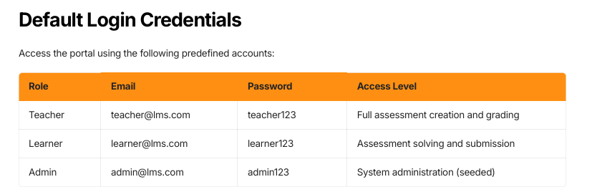

9. REST API Reference

Method | Endpoint | Description
POST | /api/auth/login | Authenticates user; checks plain-text credentials and role
GET | /api/assessments | Fetches assessments list; supports batch, timeFilter, status, role parameters
POST | /api/assessments | Saves new assessment (Teacher)
POST | /api/assessments/draft | Saves assessment as draft with DRAFT status
POST | /api/assessments/publish | Saves assessment as published with PUBLISHED status
PATCH | /api/assessments/{id}/publish | Publishes a draft assessment
DELETE | /api/assessments/{id} | Deletes assessment record (Teacher)
GET | /api/batches | Retrieves list of all training batches
POST | /api/batches | Registers a new batch (prevents name duplicates)
GET | /api/batches/{id} | Retrieves batch details by ID
PATCH | /api/batches/{id} | Updates batch configuration fields
DELETE | /api/batches/{id} | Deletes batch record
GET | /api/submissions | Fetches submissions, including dynamic virtual pending/missing records
POST | /api/submissions | Saves student attempt response
PATCH | /api/submissions/{id}/grade | Enters subjective marks score and feedback comments
POST | /api/submissions/bulk-grade | Bulk grades multiple submissions
POST | /api/submissions/bulk-reviewed | Bulk marks submissions as reviewed
POST | /api/uploads | Uploads binary files to backend storage directory
GET | /api/files/preview/{file} | Streams file inline
GET | /api/files/download/{file} | Streams file as attachment download
POST | /api/certificates/generate | Evaluates rules and generates digital certificate metadata
GET | /api/certificates/student/{id} | Retrieves list of certificates unlocked by learner ID
GET | /api/certificates/{id} | Retrieves specific certificate verification details

10. Database Schema & Collections

10.1 MongoDB Collections Overview
Collection | Purpose | Key Fields | Relationships
users | Manages system accounts and batch assignments | id, name, email, role, password, batch, rollNumber, avatar | One-to-Many with assessments and submissions
assessments | Stores assessment parameters and embedded questions | id, title, subject, batch, instructions, questionType, totalMarks, deadline, status, fileUrl, fileName, fileSize, batches (array), questions (embedded) | One-to-Many with submissions
submissions | Evaluates candidate responses and stores feedback | id, assessmentId, assessmentTitle, subject, batch, learnerId, learnerName, answers, status, marksObtained, totalMarks, feedback, submittedAt, submittedFileUrl, submittedFileName, rollNumber, deadline | Many-to-One with assessments and users
batches | Manages training groups and candidate batches | id, name, description, createdAt, updatedAt | One-to-Many with users and assessments
certificates | Stores digital credentials and verification data | id, learnerId, assessmentId, title, issuedDate, expiryDate, pdfUrl, status, verificationCode | Many-to-One with users
materials | Manages shared course documents and resources | id, title, description, fileUrl, fileName, fileSize, uploadedBy, uploadedAt, batches (array) | Many-to-Many with batches

10.2 Collection Details

users Collection
{
_id: ObjectId,
name: String,
email: String (unique),
role: String (TEACHER, LEARNER, ADMIN),
password: String (plain-text),
batch: String,
rollNumber: String,
avatar: String (URL),
createdAt: Date,
updatedAt: Date
}

assessments Collection
{
_id: ObjectId,
title: String,
subject: String,
instructions: String,
questionType: String (MCQ, WRITTEN, FILE_UPLOAD),
totalMarks: Number,
deadline: Date,
status: String (DRAFT, PUBLISHED),
fileUrl: String,
fileName: String,
fileSize: Number,
batches: [String],
questions: [
{ id: String, statement: String, marks: Number,
options: [String], correctAnswer: String }
],
createdBy: String (userId),
createdAt: Date,
updatedAt: Date
}

submissions Collection
{
_id: ObjectId,
assessmentId: String,
assessmentTitle: String,
subject: String,
batch: String,
learnerId: String,
learnerName: String,
answers: [String],
status: String (PENDING, SUBMITTED, GRADED, LATE, MISSING),
marksObtained: Number,
totalMarks: Number,
feedback: String,
submittedAt: Date,
submittedFileUrl: String,
submittedFileName: String,
rollNumber: String,
deadline: Date
}
11. Teacher Workflow & Assessment Creation Flow

11.1 Teacher Assessment Creation Workflow

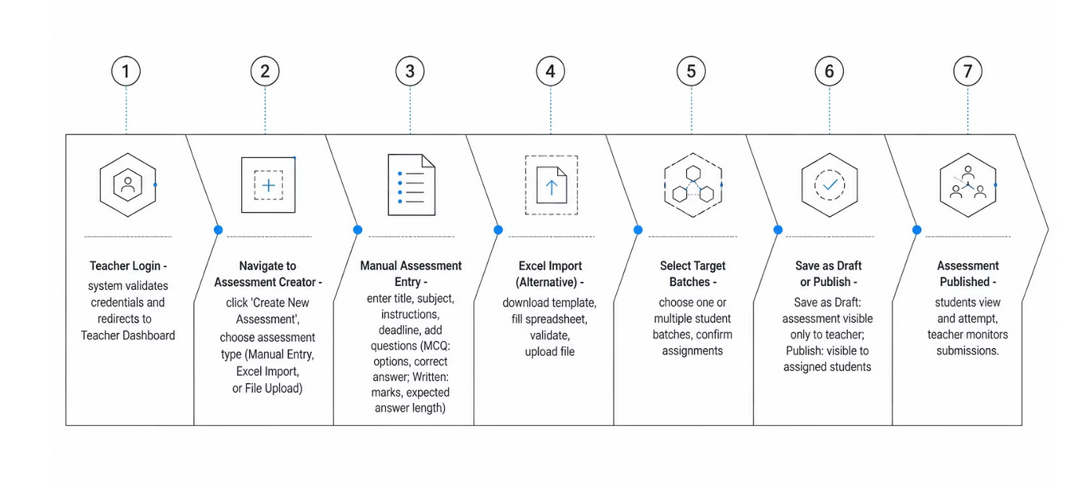

Figure 3 — Teacher assessment creation workflow
- 1. Teacher Login — system validates credentials and redirects to the Teacher Dashboard.
- 2. Navigate to Assessment Creator — click 'Create New Assessment' and choose assessment type (Manual Entry, Excel Import, or File Upload).
- 3. Manual Assessment Entry — enter title, subject, instructions, deadline, and add questions (MCQ: options and correct answer; Written: marks and expected answer length).
- 4. Excel Import (alternative) — download the template, fill the spreadsheet, validate, and upload the file.
- 5. Select Target Batches — choose one or multiple student batches and confirm assignment.
- 6. Save as Draft or Publish — a draft stays visible only to the teacher; publishing makes it visible to assigned students.
- 7. Assessment Published — students can view and attempt it, while the teacher monitors submissions.

11.2 Detailed Assessment Module Flow
A closer look at each authoring path — manual entry, custom MCQ quizzes, Excel import validation, file-upload tasks, and multi-batch publishing.
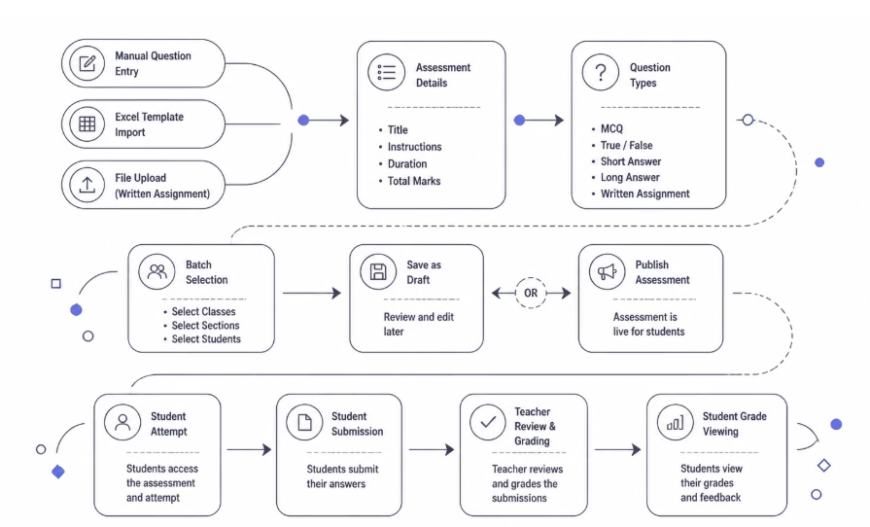

Figure 4 — Detailed assessment creation & publishing flow

11.3 Key Features During Creation
- Auto-save functionality to prevent data loss.
- Question preview before publishing.
- Batch conflict detection.
- Deadline validation (must be a future date).
- File attachment support for written assignments.

12. Student Workflow & Assessment Submission Flow

12.1 Learner Assessment Submission Workflow

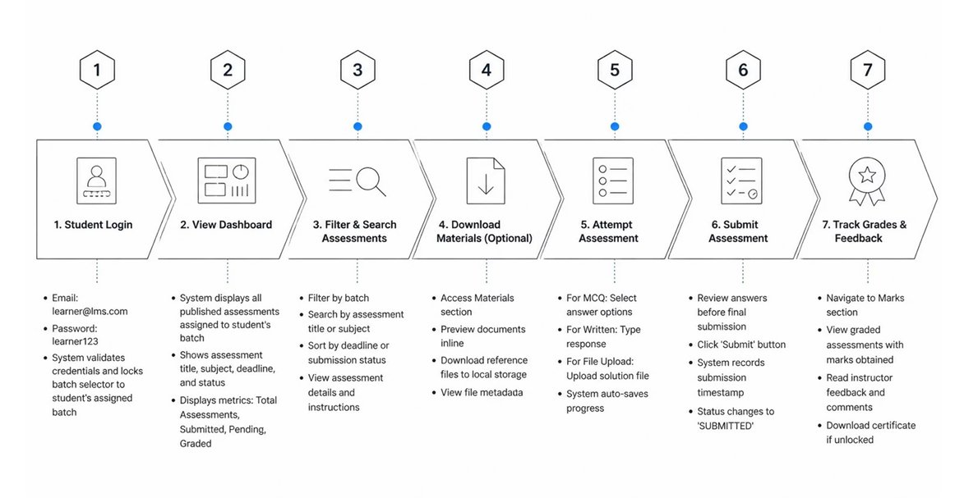

Figure 5 — Learner assessment submission workflow
- 1. Student Login — email/password validated; the batch selector is locked to the student's assigned batch.
- 2. View Dashboard — the system displays all published assessments assigned to the student's batch, along with metrics (Total, Submitted, Pending, Graded).
- 3. Filter & Search Assessments — filter by batch, search by title or subject, sort by deadline or submission status.
- 4. Download Materials (optional) — access the Materials section, preview documents inline, or download reference files.
- 5. Attempt Assessment — select MCQ options, type a written response, or upload a solution file; progress auto-saves.
- 6. Submit Assessment — review answers, click Submit; the system records the timestamp and sets status to SUBMITTED.
- 7. Track Grades & Feedback — view graded assessments with marks obtained, read instructor feedback, and download a certificate if unlocked.

12.2 Key Features During Submission
- Real-time deadline countdown timer.
- Auto-save to prevent data loss.
- File preview before upload.
- Answer review before submission.
- Late submission detection and flagging.
- Inline document preview — no external downloads needed.
13. Grading & Feedback Workflow

13.1 Teacher Grading & Feedback Process

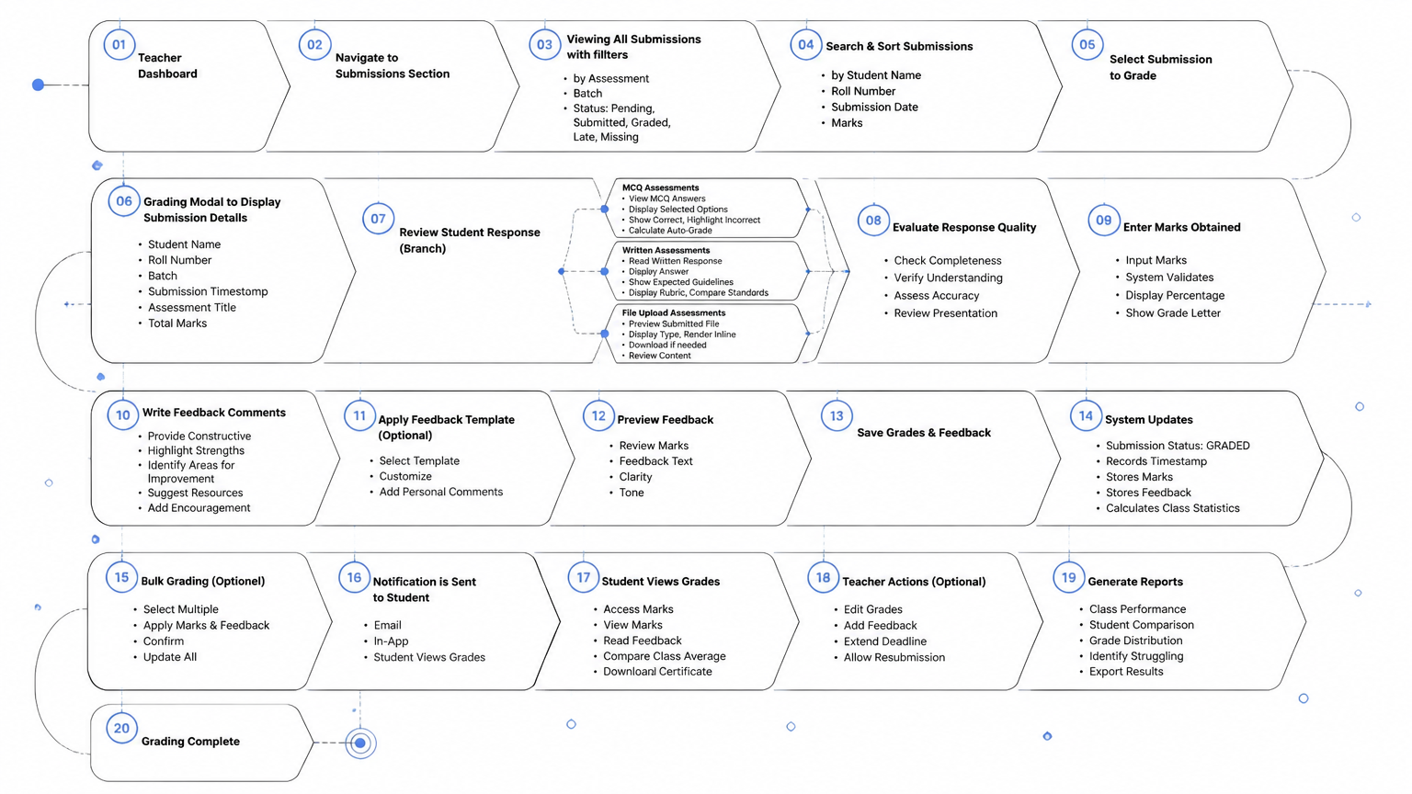

Figure 6 — Teacher grading & feedback process
- 1. Access Submissions Review Desk — navigate to Submissions, view all submissions for published assessments, filter by assessment, batch, or status.
- 2. Monitor Submission Status — Pending (not yet attempted), Submitted (awaiting grading), Graded (marks and feedback entered), Late (received after deadline), Missing (not submitted by deadline).
- 3. Select Submission to Grade — clicking a row opens the Grading Modal showing student name, roll number, batch, and submission timestamp.
- 4. Review Student Response — MCQ answers are compared against correct answers; written responses are read directly; file uploads are previewed inline (PDF, DOCX, images).
- 5. Enter Marks & Feedback — input marks obtained out of total marks, write constructive feedback, with system validation against the total.
- 6. Save Grading — clicking 'Save Grades' updates the submission status to GRADED and records a grading timestamp.
- 7. Bulk Grading (optional) — select multiple submissions via checkboxes and apply marks/feedback to all selected at once.
- 8. Generate Reports — view class performance analytics, export grades to CSV/Excel, and identify students needing intervention.

13.2 Grading Features
- Real-time marks validation.
- Rubric-based grading templates.
- Bulk operations for efficiency.
- Audit trail of grading actions.
14. File Management & Document Preview System

14.1 File Upload & Storage Flow
Step | Process | Technology Used | Output
File Selection | User selects file from local storage | HTML5 File Input | File object with metadata
Client-Side Validation | Check file type, size (max 5MB), and format | JavaScript validation | Validation result (pass/fail)
Multipart Upload | Send file to backend via POST /api/uploads | Fetch/Axios API | Upload progress tracking
Backend Processing | Spring Boot receives and validates the file | Spring Boot Controller | File stored with a timestamp prefix
Storage | File written to ./uploads directory | Local Disk Storage | File path and metadata saved
Database Record | File metadata stored in MongoDB | MongoDB | Document reference created
Response | Return file URL and metadata to frontend | REST API | {fileUrl, fileName, fileSize}

14.2 Document Preview System
File Type | Preview Technology | Rendering Method | Supported Formats
PDF | Native Browser | <iframe> with PDF.js | .pdf
DOCX | Mammoth.js | HTML conversion | .docx, .doc
XLSX/CSV | SheetJS (xlsx) | Grid table rendering | .xlsx, .xls, .csv
Images | Native Browser | <img> tag | .png, .jpg, .jpeg, .gif, .webp
Text Files | Native Browser | <pre> tag with syntax highlighting | .txt, .md, .log
Other Formats | Download Link | Forced browser download | All other formats

14.3 File Download Flow
- User clicks the 'Download' button on a file.
- Frontend calls GET /api/files/download/{filename}.
- Backend streams the file with a Content-Disposition: attachment header.
- Browser triggers the native download dialog and saves the file.

14.4 Supported File Types & Limits
- Documents: .docx, .doc, .pdf, .txt, .md
- Spreadsheets: .xlsx, .xls, .csv
- Images: .png, .jpg, .jpeg, .gif, .webp
- Maximum File Size: 5 MB per file
- Storage Location: ./uploads directory on the backend server

14.6 Key Features
- Binary-safe rendering — no external software needed.
- Inline preview without download.
- Timestamp-prefixed file naming for uniqueness.
- File metadata tracking (size, upload date, uploader).
- Secure file access with authentication.
15. Feature Modules Breakdown

15.1 Core Feature Modules
Module Name | Purpose | Key Components | User Access
Assessment Module | Create, manage, and publish assessments | Assessment Creator, Question Builder, Excel Parser, Draft/Publish Manager | Teacher (Create), Learner (View/Attempt)
File Management | Upload, preview, and download documents | File Uploader, Preview Modal, Download Handler, Storage Manager | Both (Upload/Download)
Quiz Management | MCQ authoring and interactive testing | Option Bindings, Answer Toggle, Question Outline, Test Player | Teacher (Create), Learner (Attempt)
Excel Import | Parse and validate spreadsheet templates | SheetJS Parser, Column Validator, Data Type Checker, Error Reporter | Teacher only
Submission Management | Track and manage student submissions | Submission Table, Sort Options, Search Filters, Status Tracker | Teacher (Review), Learner (Submit)
Grading & Feedback | Evaluate submissions and provide feedback | Grading Modal, Marks Entry, Feedback Composer, Bulk Grading | Teacher only
Authentication | User login and role-based access | Login Form, Credential Validator, Role Router, Session Manager | All users
Dashboard | Display metrics and quick actions | Metrics Cards, Assessment List, Submission Stats, Quick Links | Both (Different views)
Search & Filters | Find assessments and submissions | Multi-batch Checkboxes, Search Input, Time Filters, Sort Selectors | Both
Materials Management | Manage course documents and resources | Upload Interface, Preview System, Download Manager, Batch Assignment | Teacher (Upload), Learner (Access)
Marks Tracking | Monitor grades and feedback | Grades Table, Feedback Display, Certificate View, Performance Analytics | Learner (View), Teacher (Enter)
Certificates | Generate and manage digital credentials | Certificate Generator, PDF Exporter, Verification System, Archive | Learner (View), Teacher (Generate)

15.2 Module Interactions
Four core modules form the operational backbone of the portal, feeding data into one another in a continuous cycle.

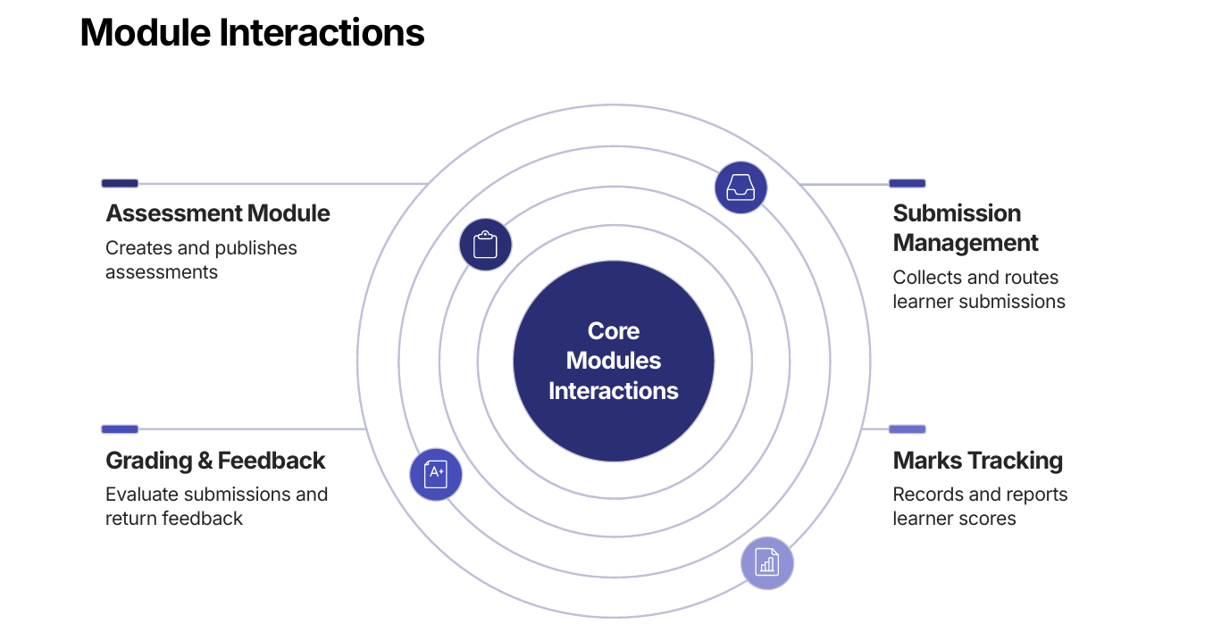

Figure 8 — Core module interactions
16. Certificate Generation Workflow

On completion of qualifying graded assessments, certificate eligibility is evaluated and metadata is generated, unlocking entries in the learner's certificate workspace with preview and PDF export opt

System Overview
The Certificate Generation System evaluates student results against defined rules and issues a digital certificate only when all requirements are met. This creates a consistent, auditable, and merit-based issuance process.
End-to-End Certificate Flow
The workflow begins when grading is complete and continues through eligibility checks, certificate creation, secure storage, student notification, verification, and expiry management.
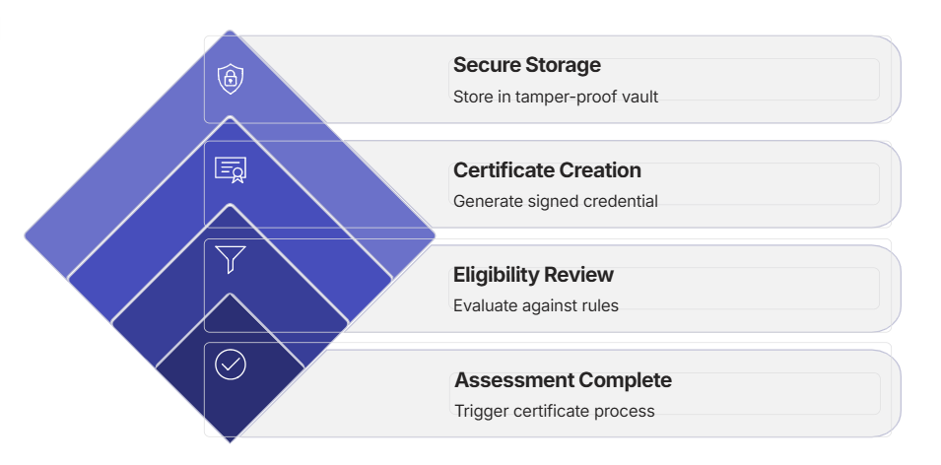
The flowchart shows both outcomes: eligible students move forward to certificate generation, while ineligible submissions are logged and optionally reported back to the student.
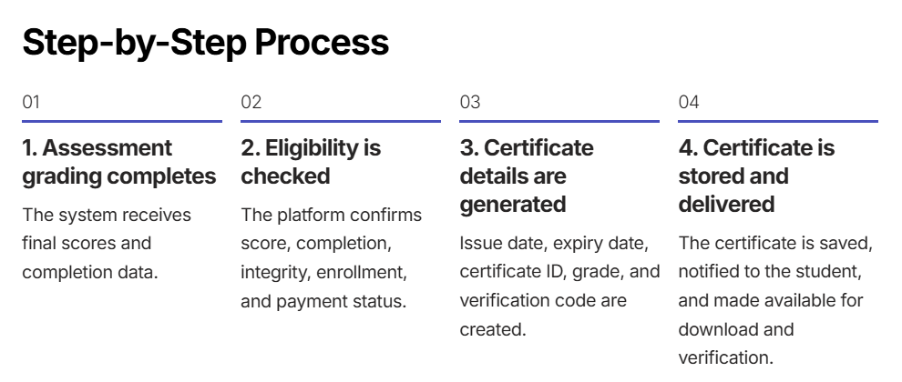

17. Deployment Guide
The Xebia LMS Assessment Portal uses a distributed deployment model with separate frontend and backend services.

17.1 Backend Deployment (Railway)
Prerequisites: a Railway account, a GitHub repository with the code, and a MongoDB Atlas cluster.
- Log in to the Railway dashboard.
- Create a new project and link the GitHub repository.
- Set the root directory to assessment-portal/backend.
- Build command: ./mvnw clean package -DskipTests
- Start command: java -jar target/assessment-portal-backend-0.0.1-SNAPSHOT.jar
- Set environment variables: SPRING_DATA_MONGODB_URI, ALLOWED_ORIGINS (Vercel URL + http://localhost:3000), PORT=8080
- Deploy and monitor logs; the backend runs at https://<railway-app-name>.up.railway.app

17.2 Frontend Deployment (Vercel)
Prerequisites: a Vercel account, a GitHub repository with the code, and a deployed backend URL.
- Log in to the Vercel dashboard and import the GitHub repository.
- Set the root directory to assessment-portal.
- Select the Next.js framework preset.
- Configure the environment variable NEXT_PUBLIC_API_URL with the Railway backend URL.
- Deploy and monitor build logs; the frontend runs at https://<vercel-app-name>.vercel.app

17.3 Database Setup (MongoDB Atlas)
- Create a MongoDB Atlas account and a new cluster (free tier available).
- Configure network access by whitelisting IP addresses.
- Create a database user with a strong password.
- Retrieve the connection URI and use it in the backend environment variables.

17.4 Production Checklist
Checklist Item | Notes
Backend deployed on Railway | Verify health endpoint
Frontend deployed on Vercel | Check build logs
MongoDB Atlas configured | Whitelist production IPs
Environment variables set | All secrets configured
CORS enabled correctly | Frontend URL whitelisted
SSL/TLS certificates | Auto-configured by platforms
Database backups enabled | MongoDB Atlas backup plan
Monitoring & logging | Set up error tracking
Performance testing | Load test before launch
Security audit | Review authentication and authorization

17.5 Monitoring & Maintenance
- Monitor backend logs on the Railway dashboard and frontend errors on the Vercel dashboard.
- Set up MongoDB Atlas alerts for database issues.
- Rely on MongoDB Atlas for regular database backups.
- Track API response times and error rates.
- Update dependencies regularly for security patches.
18. Security & Best Practices

18.1 Current Security Implementation
Security Layer | Current Implementation | Status | Recommendation
Authentication | Plain-text password validation with localStorage | Basic | Implement JWT tokens and bcrypt hashing
Authorization | Role-based access control (TEACHER, LEARNER, ADMIN) | Good | Add fine-grained permissions
Data Encryption | No encryption for data in transit or at rest | Basic | Enable HTTPS/TLS and database encryption
File Upload | Client-side validation only | Basic | Add server-side validation and virus scanning
API Security | No rate limiting or API key authentication | Basic | Implement rate limiting and API keys
Database | MongoDB Atlas with network access control | Good | Enable IP whitelisting and encryption
CORS | Configured with allowed origins | Good | Regularly review and update allowed origins
Session Management | localStorage-based sessions | Basic | Implement secure HTTP-only cookies
Input Validation | Basic client-side validation | Basic | Add comprehensive server-side validation
Error Handling | Generic error messages | Good | Avoid exposing sensitive information

18.2 Recommended Improvements

Authentication & Authorization
- Replace plain-text passwords with bcrypt hashing.
- Implement JWT (JSON Web Tokens) for stateless authentication.
- Use HTTP-only, secure cookies for session management.
- Implement multi-factor authentication (MFA) for teachers.

Data Protection
- Enable HTTPS/TLS for all communications.
- Encrypt sensitive data at rest in MongoDB.
- Use environment variables for all secrets (never hardcode).

API & File Security
- Implement rate limiting to prevent brute-force attacks.
- Validate all input on the server side (never trust client input).
- Validate file types on the server side and scan uploads for malware.

Infrastructure & Compliance
- Keep all dependencies updated regularly; use security scanning tools (OWASP, SonarQube).
- Maintain audit logs for user actions and implement data privacy controls (e.g., GDPR).
- Regular security audits, penetration testing, and disaster-recovery drills.
19. Future Enhancements & Roadmap

19.1 Planned Enhancements
Feature | Priority | Timeline | Benefit
JWT Security Integration | High | Q2 2026 | Enhanced security, industry standard
Redis Caching Layer | High | Q3 2026 | Improved performance, reduced database load
Live WebSocket Notifications | High | Q3 2026 | Better engagement, instant updates
Advanced Search & Filters | Low | Q3 2026 | Better discoverability
Containerization (Docker) | Medium | Q4 2026 | Consistent deployments, easier scaling
Advanced Analytics Dashboard | Medium | Q4 2026 | Better insights for teachers
Integration with LMS Platforms | Medium | Q4 2026 | Broader adoption (Canvas, Blackboard, Moodle)
AI-Powered Grading | Medium | Q1 2027 | Faster grading, consistency
Mobile App (React Native) | Low | 2027 | Increased accessibility
Video Assessment Support | Low | 2027 | Diverse assessment types

19.2 Technical Debt & Performance
- Refactor authentication to use JWT and bcrypt; add unit/integration tests (target 80% coverage).
- Optimize database queries with proper indexing and add API rate limiting.
- Implement database query caching with Redis and a CDN for static assets.
- Add comprehensive API documentation (Swagger/OpenAPI).

19.3 Scalability Roadmap

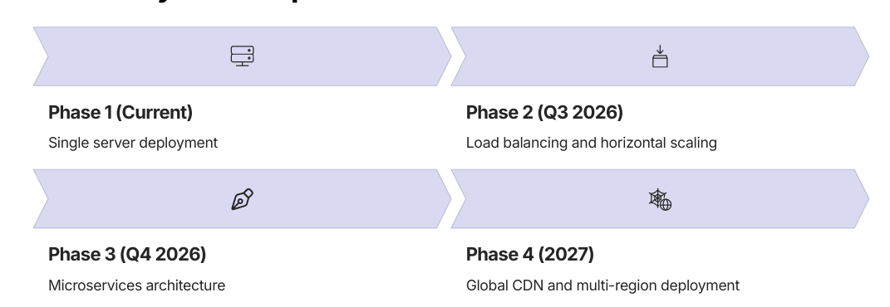
Figure 10 — Scalability roadmap phases
20. Document Summary & Quick Reference

This documentation covers all aspects of the Xebia LMS Assessment Portal, an enterprise-grade learning management system designed for streamlined academic testing and grading workflows.

20.1 Quick Links
- GitHub Repository: github.com/Pardhu643/Xebia-LMS-assessment-portal
- Default Login: teacher@lms.com / teacher123 (Teacher), learner@lms.com / learner123 (Learner)
- Local Development: http://localhost:3000 (Frontend), http://localhost:8080 (Backend)

20.2 Getting Started
- Clone the repository: git clone https://github.com/Pardhu643/Xebia-LMS-assessment-portal.git
- Configure the MongoDB URI in environment variables.
- Run the backend: cd assessment-portal/backend && ./mvnw spring-boot:run
- Run the frontend: cd assessment-portal && npm install && npm run dev
- Access the app at http://localhost:3000

